Lists in dart
Workshop #3
Flutter Developer Bootcamp

Purpose
This workshop demonstrates the basic operations on lists in Dart programming language.The code showcases basic list manipulation operations such as adding, removing, and checking for the presence of elements. It's a simple example demonstrating how to work with lists in Dart.

Problem
In the given workshop, there will be a list of your favorite animal([‘cat, ‘Dog’, ‘Lion, ‘Tiger’] and also have Remove function to remove an animal from the list(example removing dog). You need to add a new animal ‘Cheetah’ to the list and also check if the list contains a ‘Cat’ is it true or false(bool condition).
How to Solve
- Checkout the workshop from Git Repo:
git clone -b <user-branch> <repo-URL>
- Open the root folder inside VS Code
- Open the root folder in terminal
- Run the command dart run filename.dart
- Add a new animal to the list.
- Check if the list contains a specific animal.
- Go To File: <specific-file-with-list-method> à <method-name>, implement your logic.

You will Achieve
When you complete this workshop you will learn the following:
- List Creation:
A list named favoriteAnimals is defined to store strings representing favorite animals. It's initialized with four animals: 'Cat', 'Dog', 'Lion', and 'Tiger'.
- Printing the List:
The content of the list favoriteAnimals is printed using the print() function.
- Adding an Element to the List:
The add() method is used to append the string 'Cheetah' to the favoriteAnimals list.
- Removing an Element from the List:
The remove() method is used to remove the string 'Dog' from the favoriteAnimals list.
- Checking if an Element is in the List:
The contains() method is used to check if the string 'Cat' is present in the favoriteAnimals list. The result is stored in the variable containsCat.
- Printing Results:
The results of each operation (adding, removing, and checking for the presence of an element) are printed using print() statements.
- It showcases basic list operations in Dart:

- Adding elements with add().
- Removing elements with remove().
- Checking for the presence of elements with contains().
- Printing the contents of a list with print().

Screenshots

Before implementation (without adding favorite animal and checking a specific animal in list )

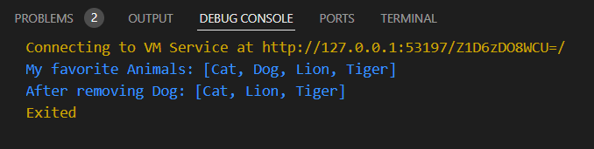

After implementation (With adding favorite animal and checking specific animal in list)

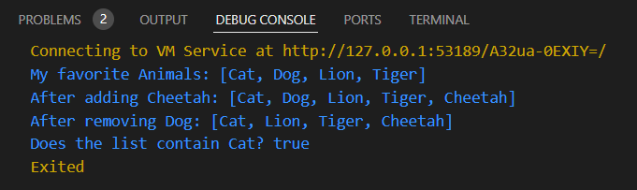

How to submit your workshop
Push your project back to the same git branch using command:
<command name>

Happy Coding!

